**Calculating the searching radius**

Un-weighted KDE method

1. **Kernel : Normal (Gaussian) Kernel**

Tools: R package **ks**

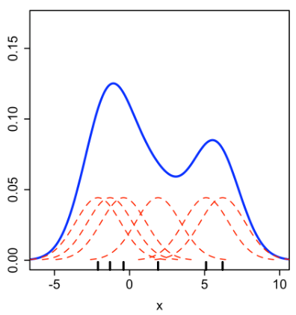

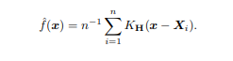

1. **Researching radius – radius matrix**

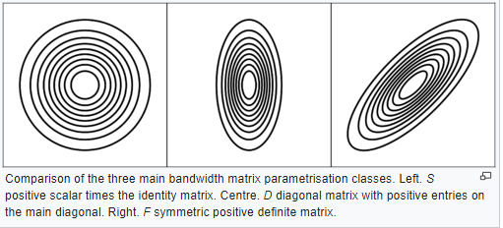

* ArcGIS default bandwidth selection

1. Calculate the mean center of the input points
2. Calculate the distance from the mean center for all points
3. Calculate the median of the distances, Dm
4. Calculate the standard distance, SD
5. Applying the following formula to calculate the bandwidth

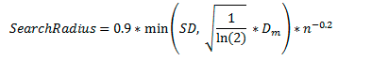

* Plug-in
* Un-biased cross validation --LSCV
* Biased cross validation -- BCV
* Smoothed cross validation – SCV

**Test**

**Brussel positive data**

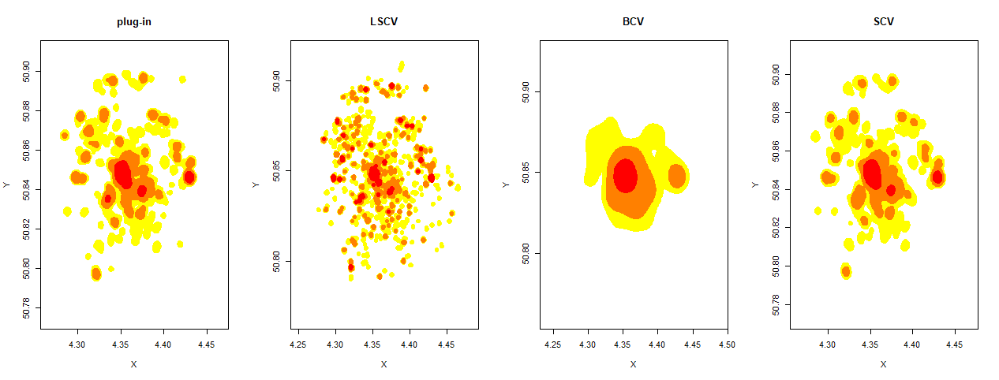

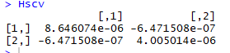

red = 25%, orange + red = 50%, yellow + orange + red = 75%

**Code**

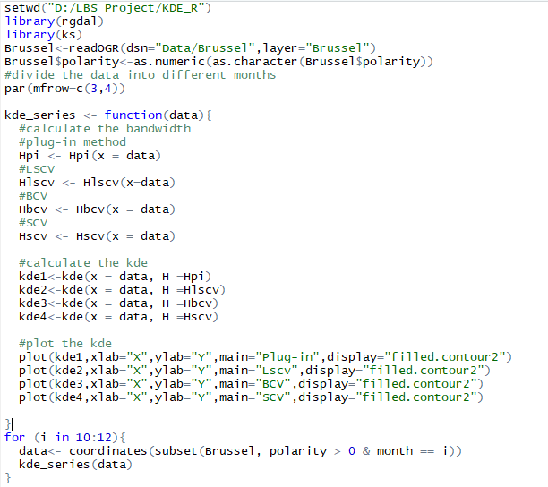

**Brussel:**

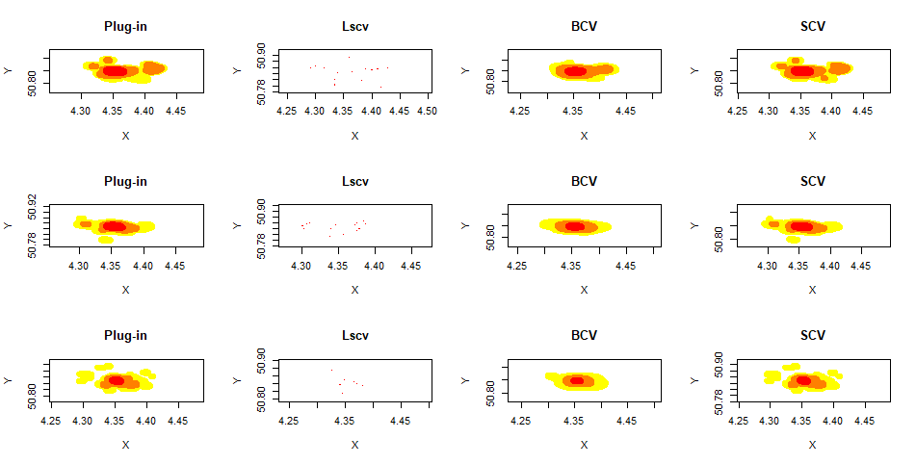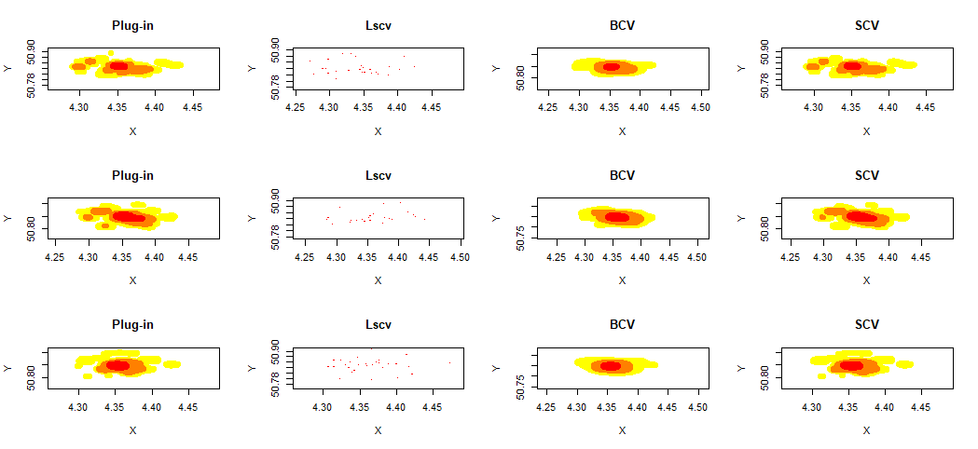

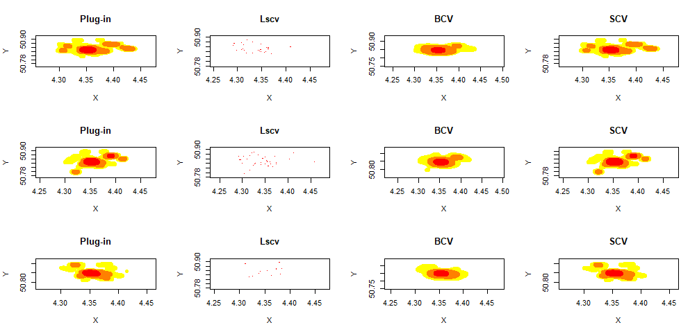

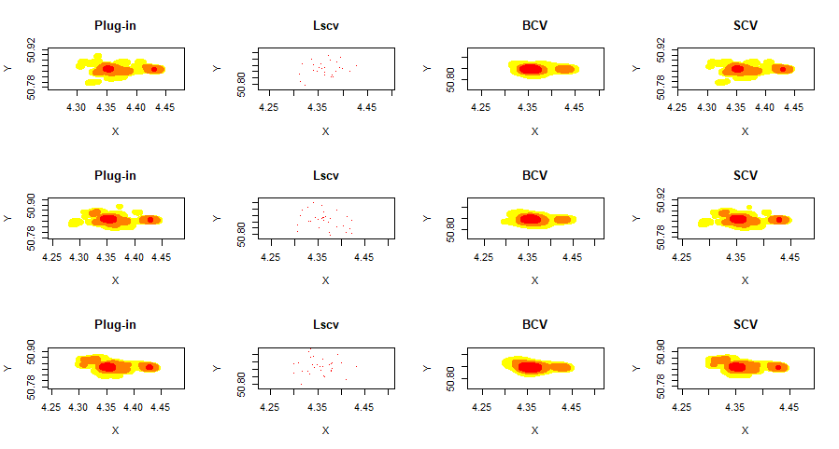

**Munich**

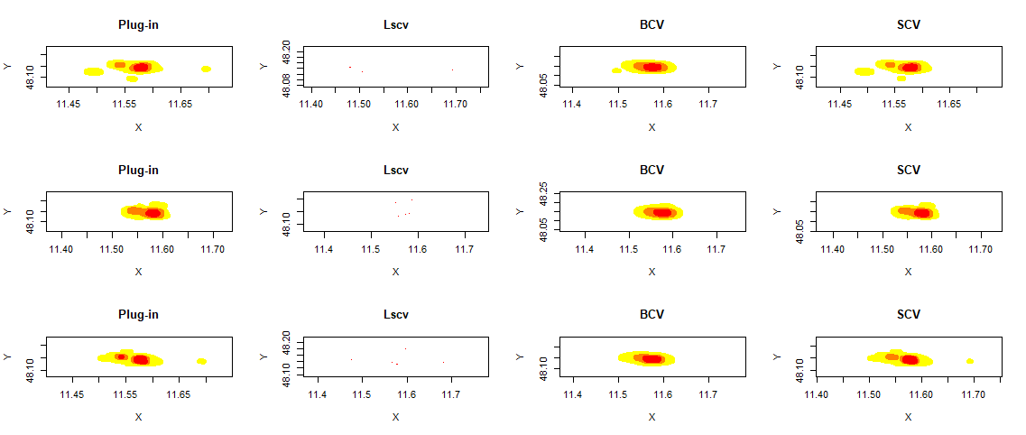

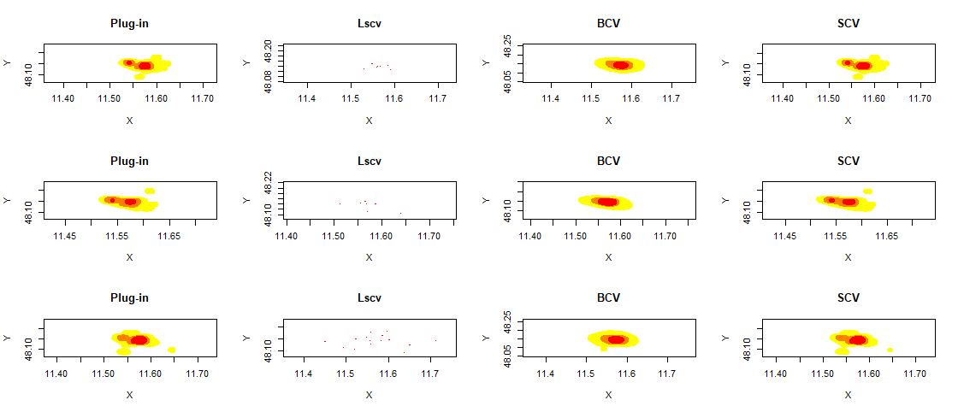

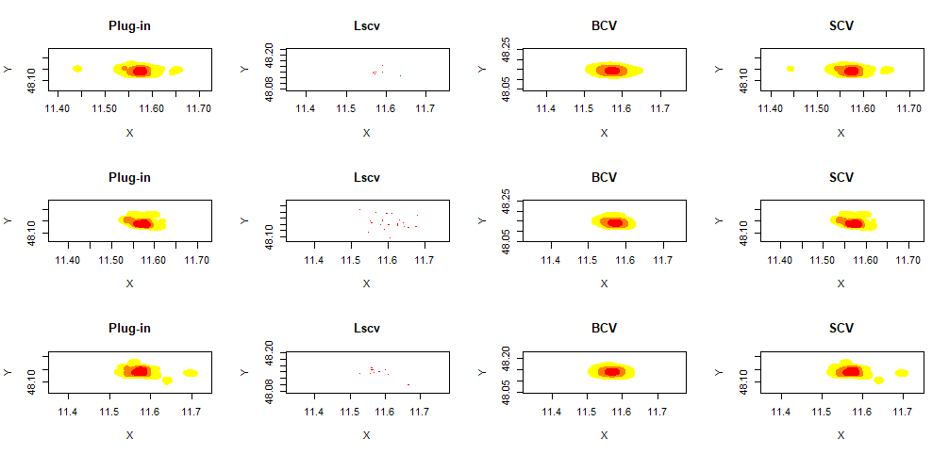

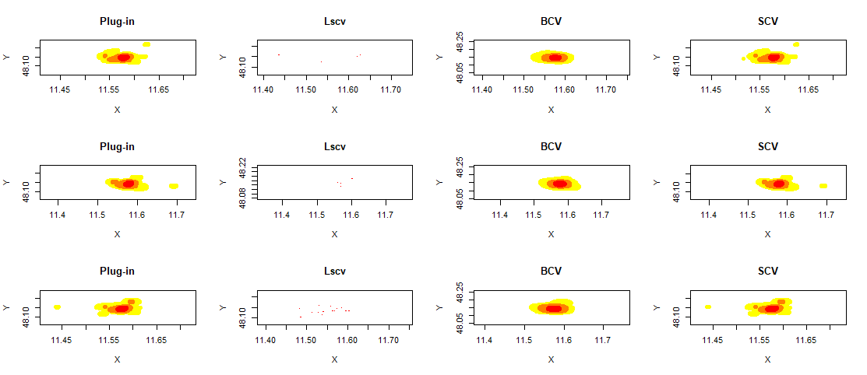

**Vienna**

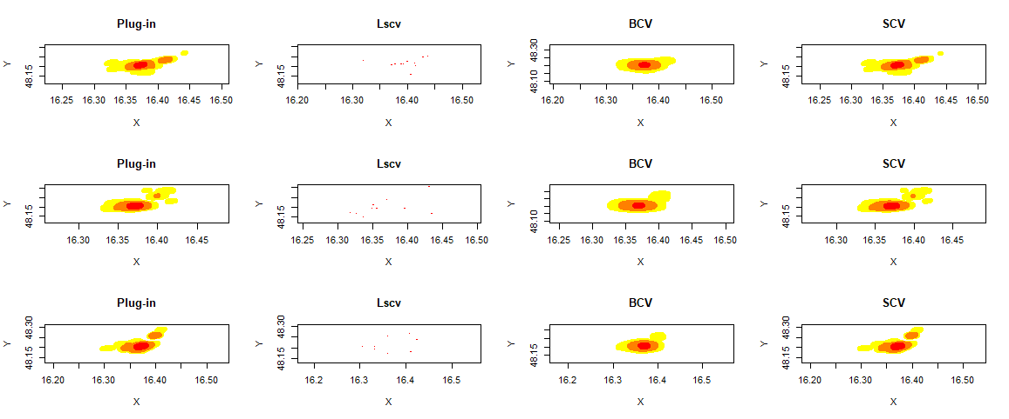

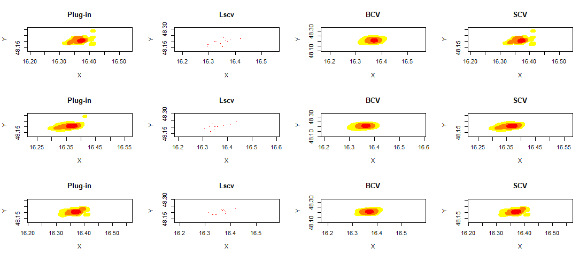

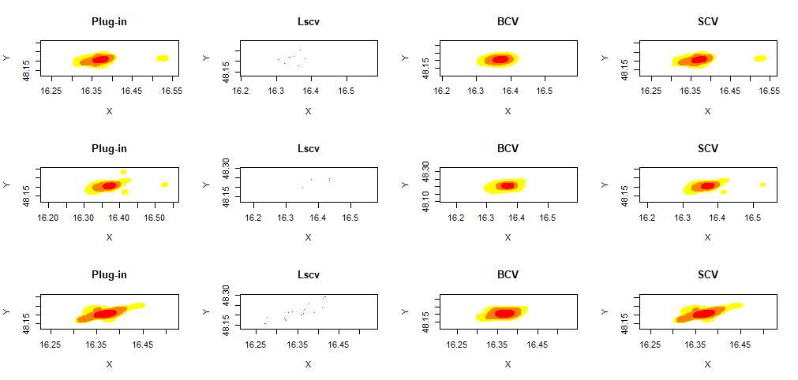

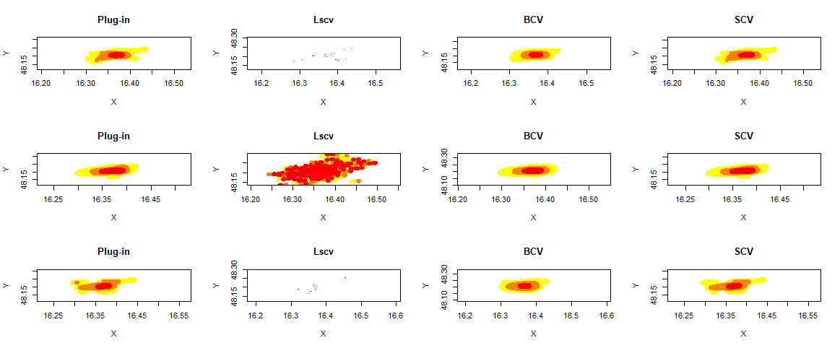

**HeatMap. JS Rendering Principle**

Blur-based map

The more points appear in the same location, the stronger color becomes